III  
Intuitive Instrument Interface

Name Jan Zuiderveld (3035503374)

Date 22 may 2018

Course ELEC3542

Introduction

III is a is an artistic / entertainment tool for interacting with music using your hands in an intuitive way. It allows users to have a more natural control of their Digital Audio Workstation (DAW), add an extra dimension to live performances, and to interact with music playfully.

Shorthand, the goals of this product can be divided in the following categories:

**Make Audio creation accessible to newcomers**

Learning to produce music has a very steep learning curve for most people. One of our main aims is to make this curve easier to overcome by providing intuitive and fun ways to control sounds.

Classic controllers and hardware can be intimidating, with as much potentiometers and IO’s crammed on the products surface. Our product tries to remove some of these barriers by making multi-parameter controlling more intuitive. The end product will come with a vast library of different control mappings, tailored to different sounds, instruments, effects, and purposes

**Boost creative workflow of professionals**

Some might think that making a tool designed to make hard things easy implies it is unnecessary for advanced users. We want to argue that this is not the case, and we won’t compromise flexibility for accesibility. Luckily this doesn’t have to happen; We believe intuitive tools boost anyone’s workflow

**live performances**

usually when playing any instrument, there’s no time to reach out to knobs for sound manipulation, let alone multiple knobs. Pedals are used as toggles or wah wah effects, but our feet are in general not the most precise limbs. With Tri we try to create more space in these situations for improvisation

The setup of electronic live performances, or dj sets, mostly doesn’t allow to see what the artist is actually doing. As far as you know they might be doing their email. With tri we open up this interesting part of live perfomances and allow artists to visualize what they’re doing on stage

**Finalized System Architecture**

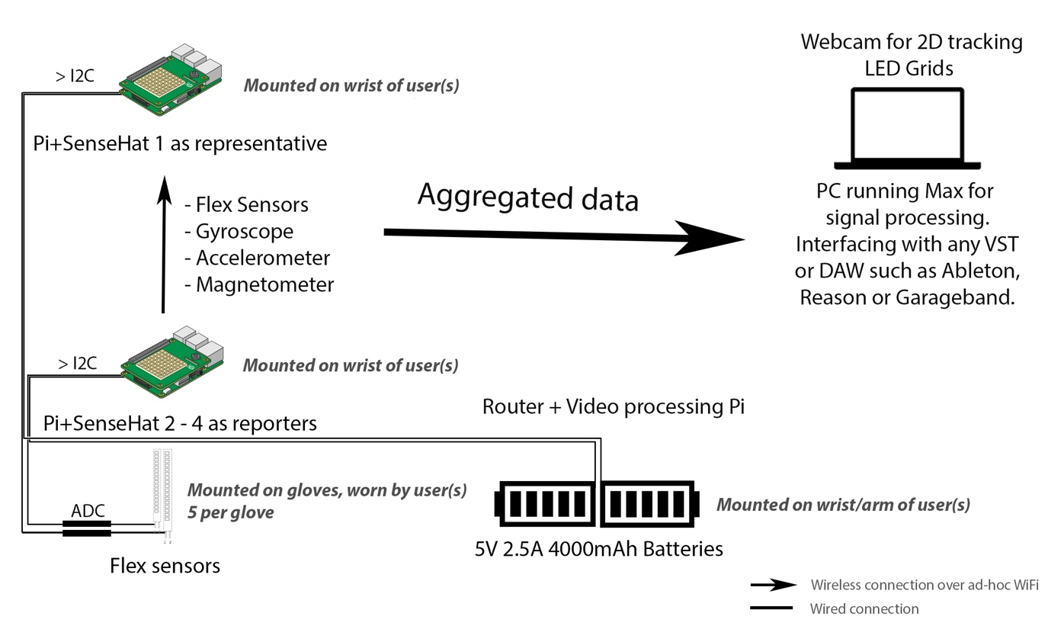

Work Accomplished and Performance Analysis

**The finished prototype:**

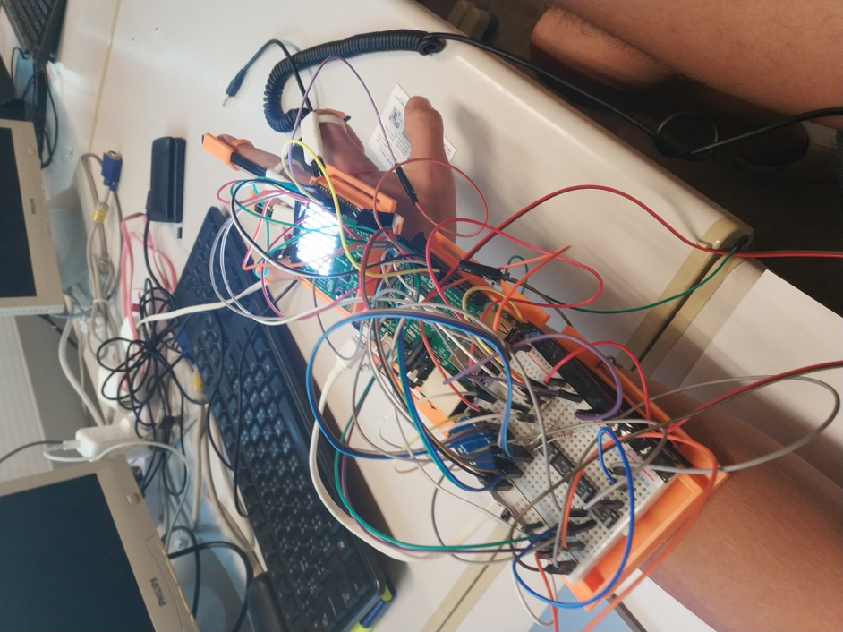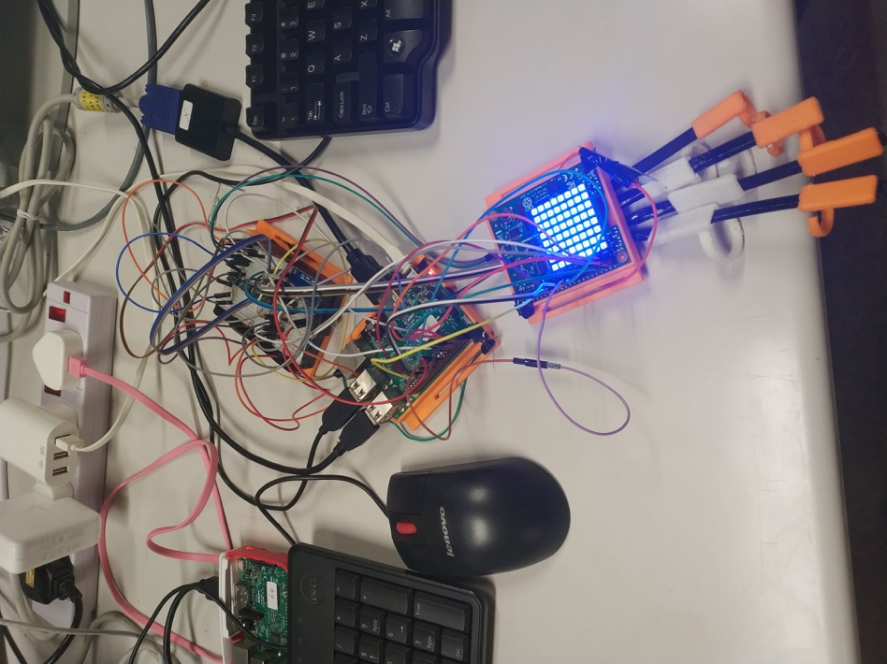

* The sense hat is attached to the top of the hand with a 3D printed case, without pi to minimize bulk.
  + Orientation of the hand is measured by the accelerometer, gyroscope and compass
  + The LED grid can be tracked by pc webcams for 2D positional coordinates. In daylight bright white worked best, without daylight soft green light worked best
* The flex sensors are mounted on the fingers using 3D printed rings. These are wired to the breadboard, in voltage divider circuits, which are wired to a 4 channel 12-bit ADC.
* All the variables measured on the glove are measured using a python script [glove.py], which also sends the data over UDP. Collection time is ~3ms. Sending time is not totally stable, but at good moments averaging ~25ms.
* Further data processing is done in Max, a visual programming language based on C.
* Wekinator, a machine learning tool based on Weka, is implemented inside Max for gesture recognition.
* Max patch is configured to output in MIDI, which can be read by any digital audio workstation, I used Ableton.

All the needed communication for one hand is working. Final implementation for Ableton is not finished. Responsiveness is OK but needs improvement.

Challenges in Implementation & Possible Future Development

* Data collection speed on the glove could be improved by using dedicated ADC’s, relatively a lot of speed is lost during data collection in channel switching.
* Transfer speeds can be improved by using a Wi-Fi Direct implementation. Will also make the setup more convenient.
* Currently the prototype is quite fragile, bulky, and hard to get on your hand. Also the 3D printed rings are not ideal, uncomfortable for finger and flex sensors. 1 broke during development. For a future model it would be a good idea to implement real gloves.
* 2D position works allright, but could be made more robust by using a camera from above or multiple camera’s and a more specific pattern on the led grid.